**Flight Delay Analysis Report**

**Introduction**

This report analyzes different types of flight delays across airlines, airports, and times of day. The purpose is to identify the main reasons behind these delays and suggest practical measures to reduce them.

**Types of Flight Delays**

Before discussing the results, here are the main delay types included in the analysis:

* **Carrier Delay:** Caused by the airline itself, such as maintenance problems, crew delays, baggage handling, or fueling issues.
* **Weather Delay:** Caused by bad weather conditions such as fog, storms, or snow that make it unsafe to fly.
* **NAS (National Airspace System) Delay:** Caused by air traffic control congestion, airport capacity limits, or route restrictions.
* **Security Delay:** Caused by security checks or incidents that delay boarding or departure.
* **Late Aircraft Delay:** Happens when an aircraft arrives late from a previous flight and causes the next flight to also be late.

**Insights and Recommended Measures**

**1. Major Causes of Delays**

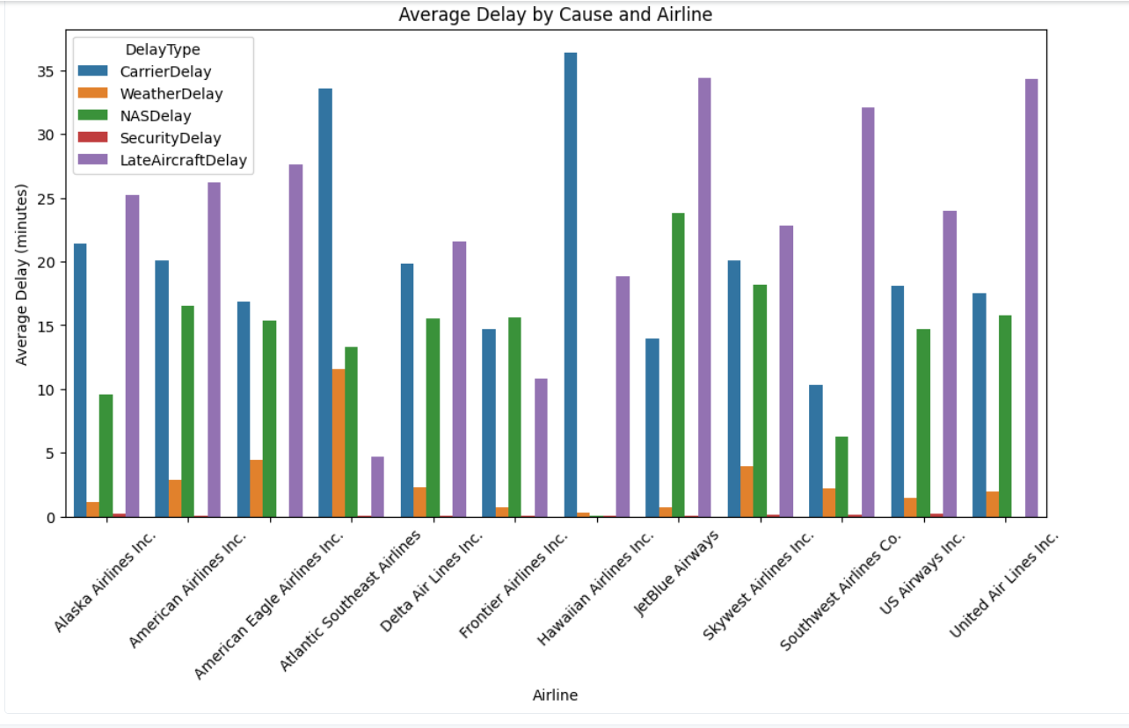

**Insight:**

**Average Delay by Cause and Airline**

* **"Late Aircraft Delay"** is often the **biggest cause** of average delays for many airlines, shown by the tall purple bars.
* **"Carrier Delay"** (blue bars) and **"Late Aircraft Delay"** (purple bars) are the most significant average delays across most airlines.
* **American Eagle Airlines Inc.** and **Frontier Airlines Inc.** stand out with particularly high average "Late Aircraft Delays".
* **JetBlue Airways** has a high average **"Carrier Delay"**.
* **Weather, NAS** (National Airspace System), and **Security** delays are generally much smaller on average than Carrier and Late Aircraft delays for most airlines.

**Distribution of Major Delay Types (Box Plot, Bottom):**

* All three major delay types—**CarrierDelay, WeatherDelay, and NASDelay**—have a **lot of very long, unusual delays** (outliers), shown by the scattered dots above the main boxes.
* The **median** (middle) delay time for all three is very low, near zero, meaning *most* delays are short or non-existent.

**Measures:**

* **Add buffer time** between flights, especially in early morning schedules, to prevent small delays from affecting later flights.
* **Improve ground operations** such as baggage handling and refueling to reduce Carrier Delays.
* **Ensure enough maintenance staff and reserve crew** to handle unexpected issues quickly.

**2. Delay Patterns**

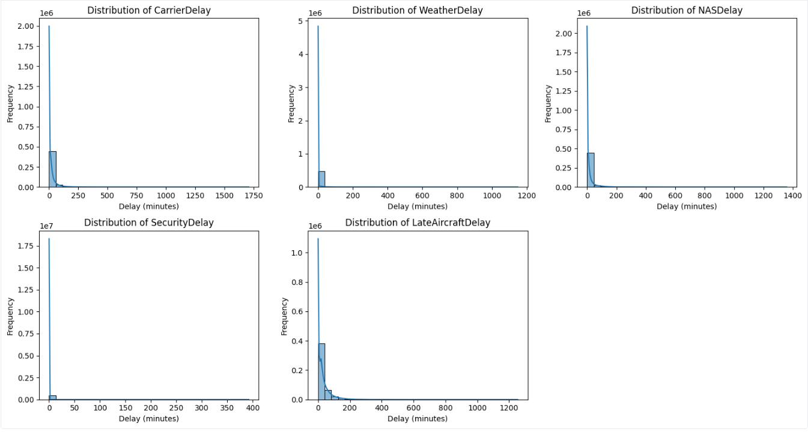

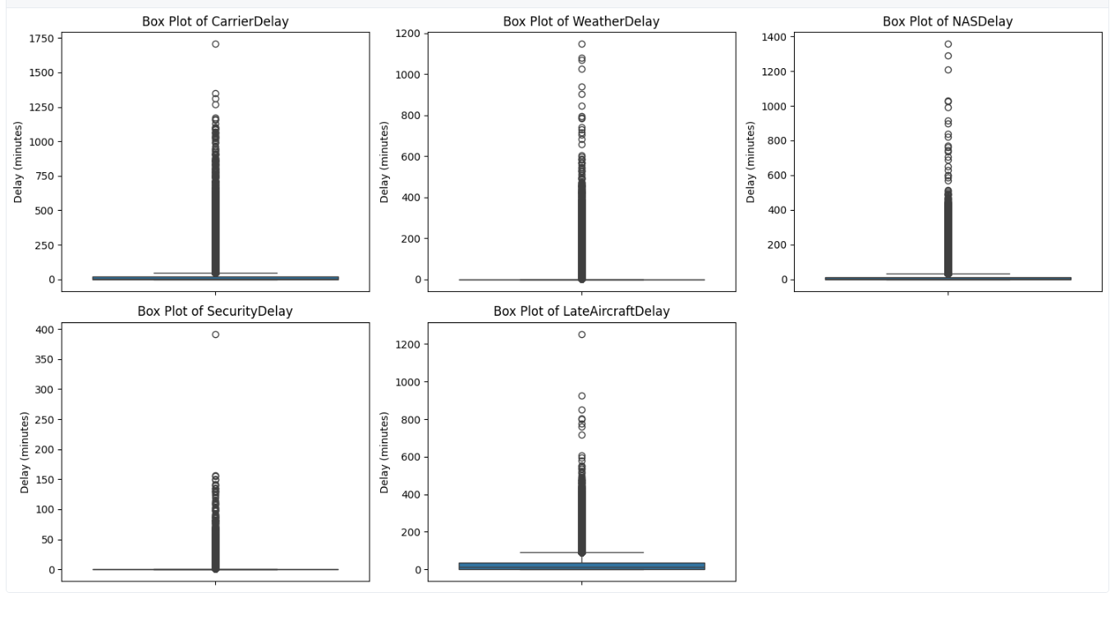

**Insight:**

* **Delay Distributions:**
* For all delay types, the vast majority of delays are very short, close to 0 minutes, indicated by the huge bars near the y-axis.
* This confirms that extreme, long delays are rare, but they do happen.
* **Delay Box Plots:**
  + The box plots for all five delay types (Carrier, Weather, NAS, Security, Late Aircraft) confirm that most delays are concentrated near the bottom (0 minutes), but there are many extreme outliers (long delays) stretching up the graph.

**Measures:**

* **Monitor outliers closely:** Identify and study flights with unusually long delays to find specific causes.
* **Set up early-warning systems** to flag flights that exceed normal turnaround times so staff can act faster.

**3. Time of Day Impact**

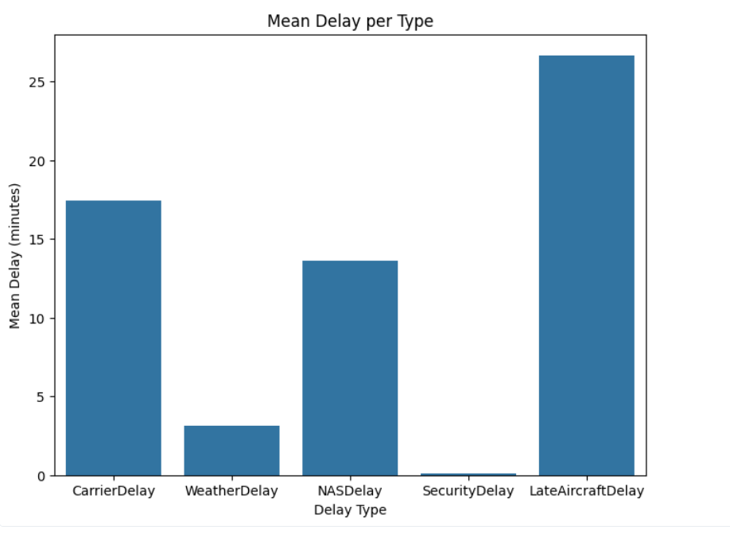

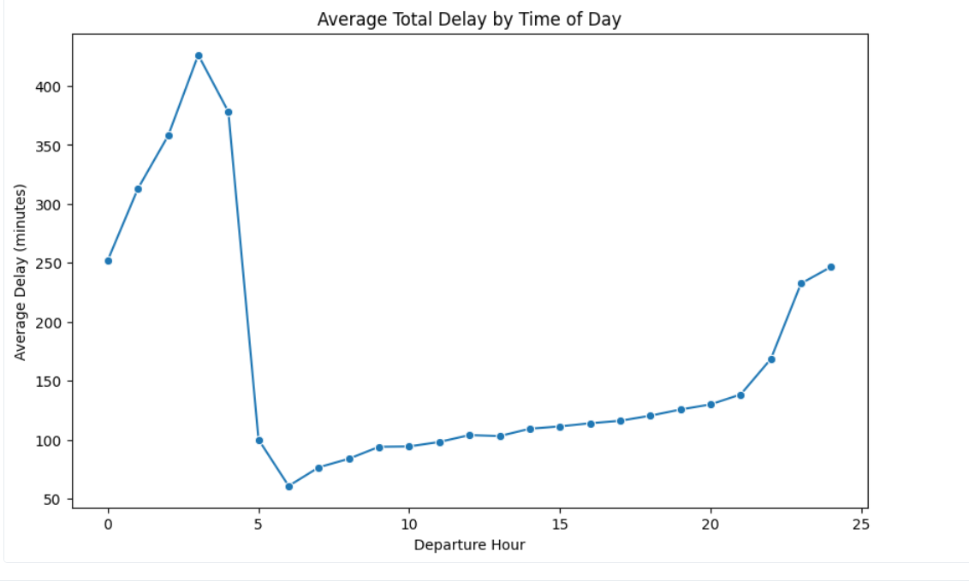

**Insight:**

* **Mean Delay per Type (Bar Chart, Top):**
  + "Late Aircraft Delay" has the highest average (mean) delay time, around 26 minutes.
  + "Carrier Delay" is the second highest, around 17.5 minutes.
  + "Security Delay" has the lowest average delay, near 0.
* **Average Total Delay by Time of Day (Line Chart, Bottom):**
  + The total average delay is highest in the early morning hours (Departure Hours 3 to 4), peaking around 400 minutes (nearly 7 hours).
  + Delays drop sharply around hour 5, and then stay low and stable through the main hours of the day (roughly 7 to 18).
  + Delays start to increase again late at night (from hour 21 to 24).

**Measures:**

* **Reschedule early morning flights** at major airports like O’Hare and LAX to slightly later times to reduce congestion.
* **Prepare a late-night recovery plan** by assigning standby crews and maintenance teams to handle aircraft arriving late at night.

**4. Airline and Airport Performance**

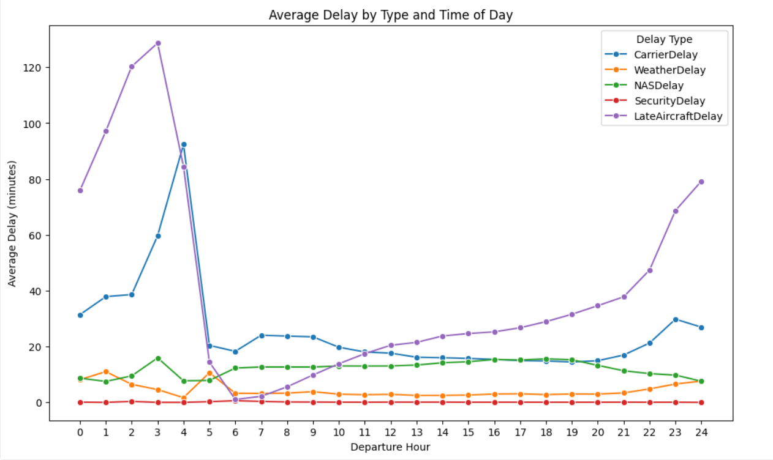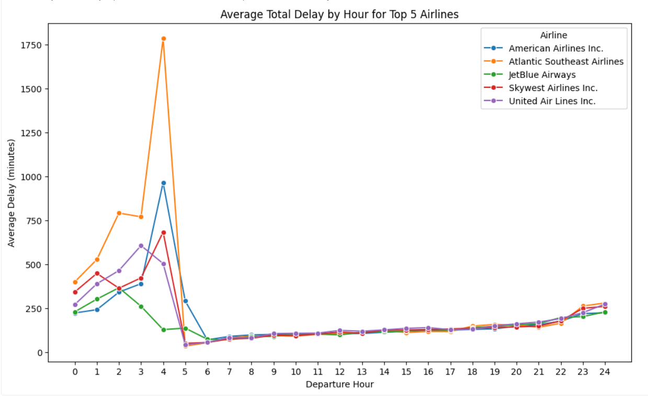

**Insight:**

* **Average Delay by Type and Time of Day:**
  + The **early morning peak** (Hours 3 to 5) in total delay is almost entirely driven by **"Late Aircraft Delay"** and **"Carrier Delay"**.
  + During the stable daytime hours (around 7 to 20), **"NAS Delay"** has the highest average, though it's still low.
  + The **"Late Aircraft Delay"** starts to build up again late in the day, causing the late-night increase in total delay.
* **Average Total Delay by Hour for Top 5 Airlines:**
  + **Atlantic Southeast Airlines** and **American Airlines Inc.** experience extremely high average total delays during the **early morning** (Hours 3 to 5), with Atlantic Southeast reaching over 1750 minutes (nearly 30 hours!).
  + Delays are generally **low and similar** for all top airlines during the core daytime hours.

**Measures:**

* **Target problem airlines and airports** with specific improvement programs.
* **Increase early morning staffing levels** at O’Hare and LAX to handle high-delay periods.
* **Review airline schedules** to avoid having too many flights departing at the same time during peak hours.

**5. Top Delay-Prone Airports**

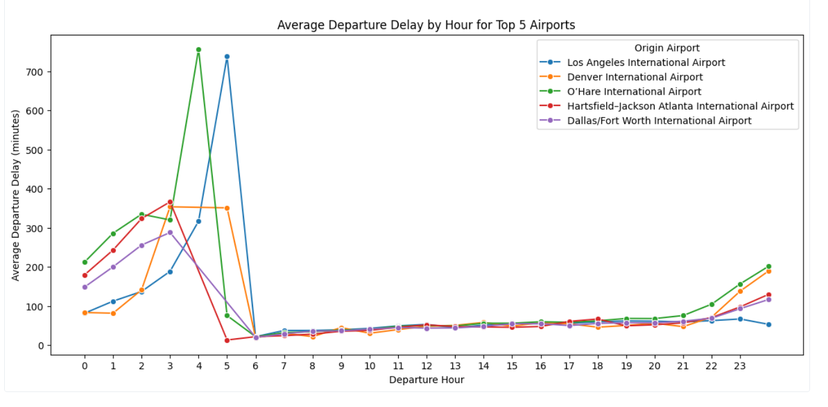

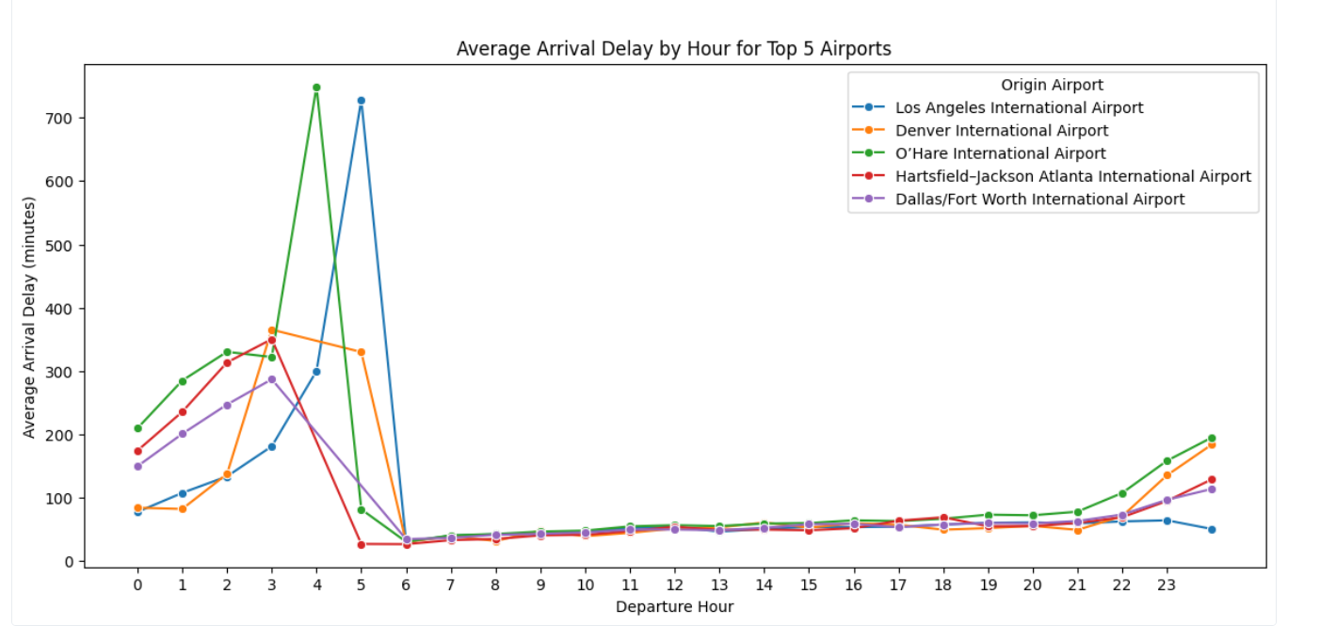

**Insight:**

**Departure and Arrival Delays by Hour for Top 5 Airports:**

* Similar to the airline data, all top airports (Los Angeles, Denver, O'Hare, Hartsfield-Jackson Atlanta, Dallas/Fort Worth) see their **highest average departure and arrival delays** in the **early morning** (Hours 3 to 5).
* **O'Hare International Airport** and **Los Angeles International Airport** show the most **extreme peaks** in both departure and arrival delays during this early morning period.
* Delays are **low and stable** during the day and start to increase again late at night.

**Measures:**

* **Investigate operational issues** at ACY to understand the cause of long delays.
* **Enhance coordination** between airlines and airport authorities to speed up ground handling and departures.
* **Introduce stricter performance monitoring** at airports with high average delays.

**6. Correlation Between Delay Causes**

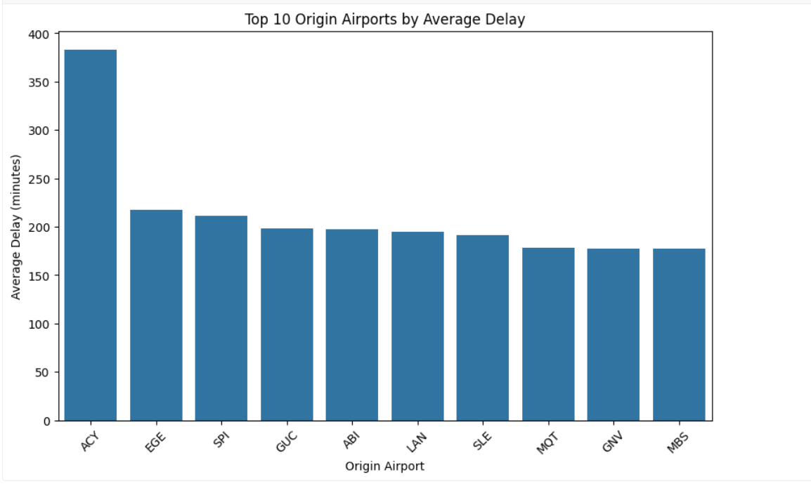

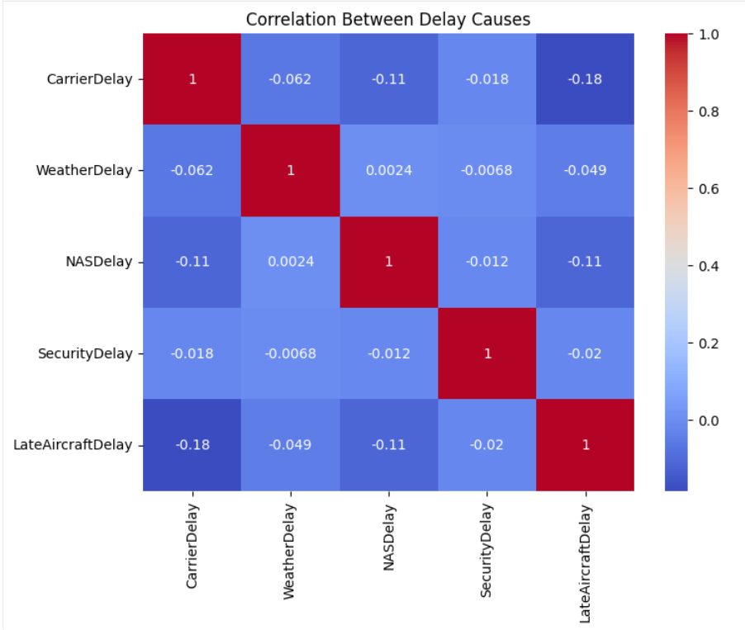

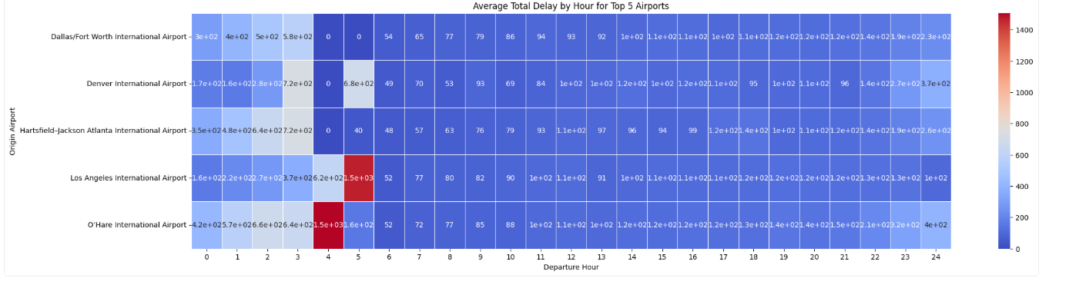

**Insight:**

* **Top 10 Origin Airports by Average Delay (Bar Chart, Top):**
  + **ACY** (Atlantic City International Airport) has the **highest average delay** among the top 10 origin airports, at over 350 minutes.
  + The other top airports have average delays between 175 and 225 minutes.
* **Correlation Between Delay Causes (Heatmap, Bottom):**
  + All delay causes show **very weak negative or near-zero correlation** with each other.
  + This suggests that an increase in one type of delay (e.g., Weather Delay) is **unlikely to directly cause** or be linked to a predictable change in another type of delay (e.g., Security Delay).

**Measures:**

* **Create separate management plans** for each delay type instead of a one-size-fits-all approach.
* **Prepare weather-specific strategies** (like standby runways or diversion plans) since weather delays are independent and unpredictable.

**7. Airline Comparison**

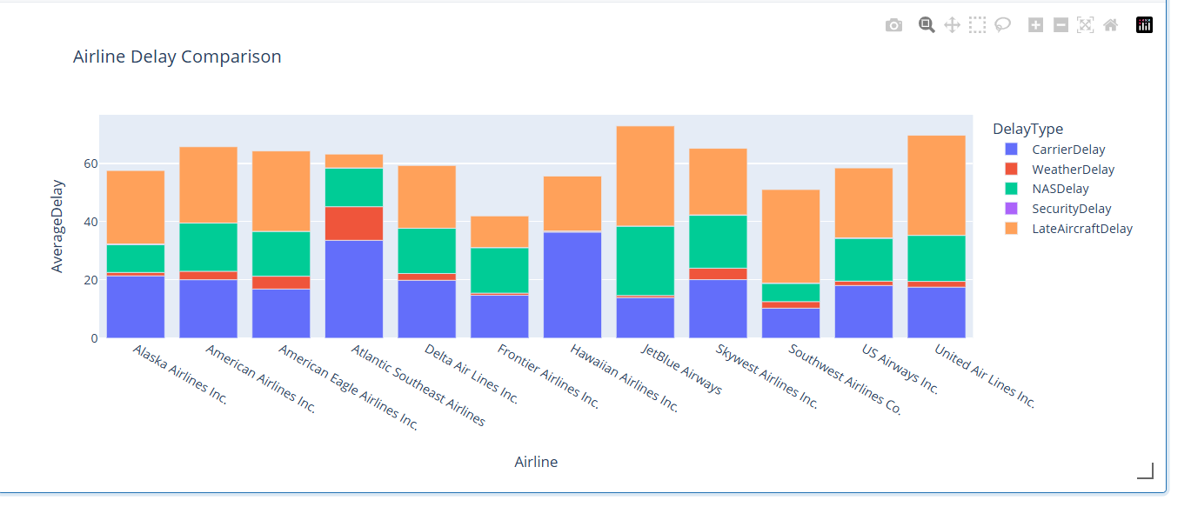

**Insight:**

* **Airline Delay Comparison (Stacked Bar Chart, Bottom):**
  + The **total average delay** varies between airlines, but **Hawaiian Airlines Inc.** appears to have the highest total average delay.
  + **Carrier Delay** (blue) and **Late Aircraft Delay** (purple) are the **largest components** of the average total delay for almost every airline.
  + **JetBlue Airways** has a particularly large average **Carrier Delay** component.

**Measures:**

* **Work with high-delay airlines** like Hawaiian and JetBlue to review maintenance and crew scheduling.
* **Encourage sharing of best practices** from low-delay airlines to help others improve.
* **Introduce performance-based incentives** to motivate airlines to reduce their delay times.

**Conclusion**

The analysis shows that **Late Aircraft** and **Carrier Delays** are the main causes of total delay time, especially during early morning hours.  
By improving scheduling, ground operations, staff readiness, and weather planning, airlines and airports can greatly reduce both the frequency and duration of flight delays.  
A focus on the worst-performing airlines and airports, along with better coordination and planning, will lead to more reliable and on-time flight operations.